AQRA MEMBERSHIP FORM
Membership Type: 1. Silver (P500 annually) | 2. Gold (P5,000 for lifetime membership)
Today’s Date:
First name: | Last name:
Highest degree:
Institution affiliation:
Major field of expertise: | Research interest(s):
Preferred complete address:
Country:
Email address 1:
Email address 2:
Telephone number: | Cell phone number:
Primary status:  --- Student  --- K-12 teacher  --- K-12 administrator | --- College/university faculty  --- College/university administrator  --- Other (specify)________________________
Who encouraged you to join AQRA?

===============PLEASE CUT HERE THEN KEEP THE PART BELOW================
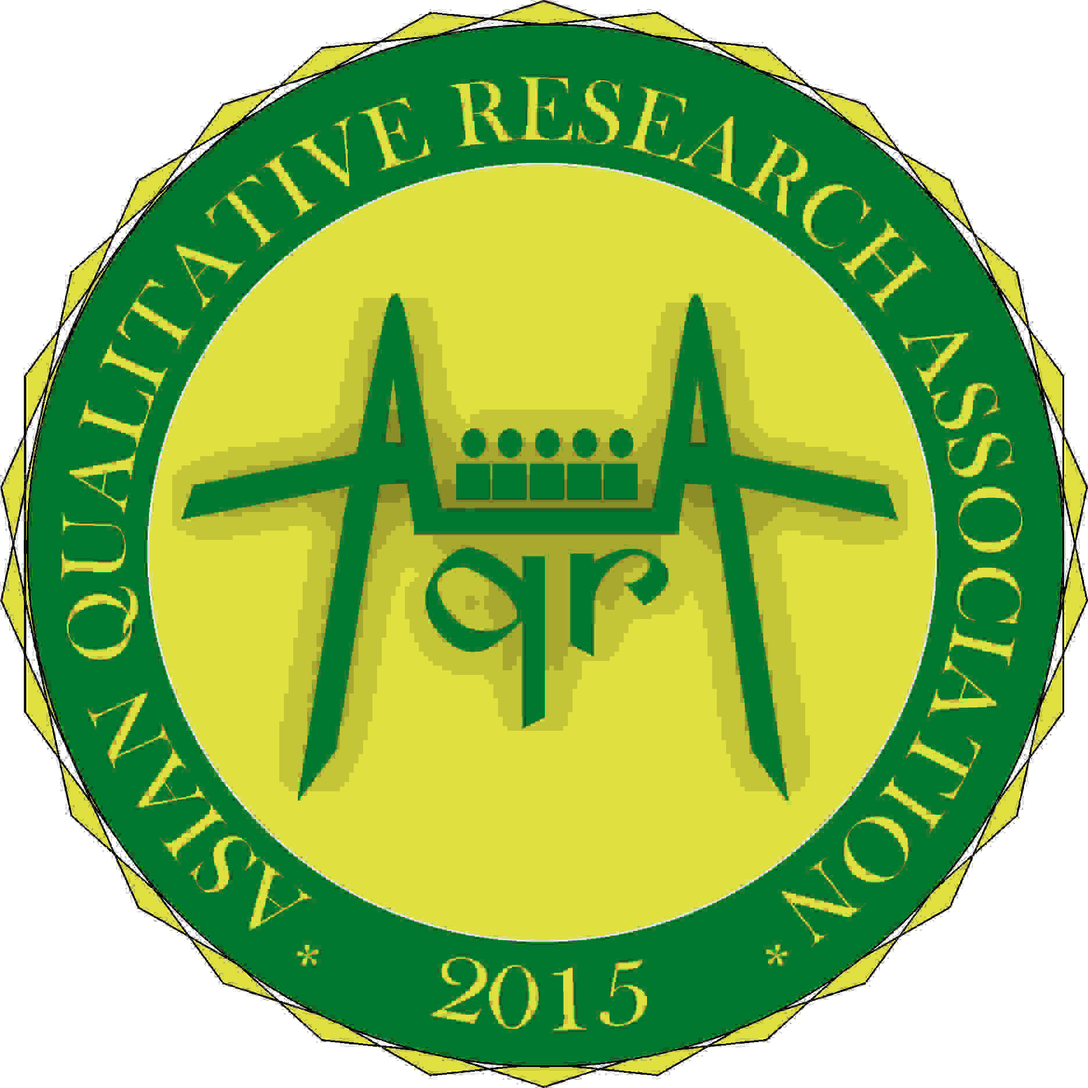
ASIAN QUALITATIVE RESEARCH ASSOCIATION (AQRA)

Adventist International Institute of Advanced Studies
Lalaan I, Silang, Cavite, Philippines
aqra@aiias.edu || (63)917-502-7369 || www.myAQRA.org

Vision: To be the leading qualitative research association in Asia and beyond.
Mission: To promote QLR and develop QLR scholars.

Objectives:
  - To set high standards of professional and ethical QLR;
  - To continually develop research skills of AQRA members through seminars, workshops, and conferences;
  - To provide a platform for interaction of faculty and students for QLR;
  - To provide research grants for the conduct of QLR studies.
  - To promote dissemination of QLR through assistance in scholarly publication.
Note: Silver membership is good for 1 year only. Benefits: Electronic certificate, access to QLR materials & experts, mentorship from AQRA, eligibility for grants, possibility of being an AQRA speaker/mentor discounts at AQRA events, co-hosting of events, etc.

